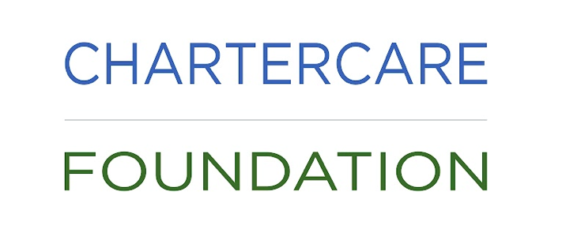
Isabella Dora Corcelli Memorial Fund
Application for Quality of Life Needs Grant

This fund will award up to $2000 per patient to enhance their quality of life during cancer, and other life-saving medical treatments. Grants open to female applicants, Rhode Island residents only, between 18 and 25 years old to mirror Isabella’s journey.
Application deadline will be posted on the website; please visit: www.chartercarefoundation.org.
Patient Name_________________________________________________ Age_____________
Address_______________________________________________________________________
City/State/Zip__________________________________________________________________
Email_________________________________________________Cell Phone_______________
Treating Physician______________________________________________________________
Name/location of treatment facility_______________________________________________
Nature of grant request: (Ex: laptop, wig, music, books, etc.) Please state need and reason.
_____________________________________________________________________________
_____________________________________________________________________________
_____________________________________________________________________________
_____________________________________________________________________________
_____________________________________________________________________________
Signature of applicant___________________________________Date____________________
Please submit your application to: grants@chartercarefoundation.org or mail to: Chartercare
Foundation, 7 Waterman Avenue, North Providence, RI 02911, Att. Executive Director.

